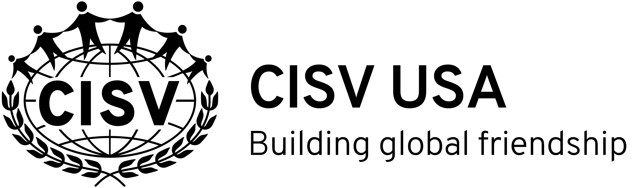

Youth Delegate Reference Form
CISV, Inc.

The following is a recommendation for , a youth applicant for a CISV program.
(APPLICANT’S FIRST & LAST NAME)
The youth is applying for (please check one):
 Village (Peace education camp for 11 year old’s)
 Step Up (Peace education camp for 14 or 15 year old’s)
 Interchange (Peace education exchange program for 14-15 year old’s)
 Seminar Camp (Peace education camp program for 16-17 year old’s)
 Youth Meeting (Peace education camp program for 12-13 year old’s)
If selected, the youth applicant will represent both the United States and his/her own area in an international setting. The local CISV USA Chapter requests your help in identifying applicants who exhibit leadership qualities and can represent their own culture successfully.
This form must be completed and returned no later than .
Please email the completed form to the Chapter contact person:
Name:
Street:
City: State: Zip:
Chapter contact person’s e-mail address:
Chapter contact person’s phone number:
*************************************************************************************************************
Name of the adult completing this reference form:
Occupation: Home/Cell Phone: E-mail address:
Capacity in which you know the youth applicant:
If you are the youth applicant’s current teacher, what is your school’s name?
What is your school’s phone number?
Length of time you have known the youth applicant:
Please check all traits in the list below that you consider to be characteristic of the youth applicant.
Then circle the five adjectives you feel describe the youth applicant’s greatest strengths.

mature independent responsible expressive accepting discerning shows initiative optimistic pessimistic responsive cooperative cautious curious attentive practical helpful participates needs coaxing caring spontaneous reticent open-minded respects adults respects peers follower leader team player fair-minded organized dependent creative quiet secure vivacious sensitive forgetful introspective friendly articulate accepted unusual sincere healthy confident tolerant compromiser intense mild-mannered patient hurried studious motivated disrespectful athletic artistic outgoing inward intolerant flexible follows direction fun conscientious shares talkative adventurous

Use this space to elaborate on any of the traits circled above or to share any concerns. Keep in mind that we are looking for youth who complement each other when forming program delegations. There is no set profile of a “typical” or “ideal” youth delegate.

Do you know of any special talents or experiences that would help this youth applicant contribute to an international program?

To the best of your knowledge, does this youth applicant have any emotional or behavioral characteristics that would interfere with his/her successful completion of a CISV program?
Behaviors that are never acceptable in any CISV program include illegal acts, alcohol/drug abuse, dishonesty, prejudice or intolerance, violence or lack of self-control, sexual contact, verbal abuse of others, and inability to handle a reasonable amount of stress. If you have seen the youth applicant exhibit such behaviors, please explain in the space below or call the Chapter contact person at the phone number listed on the front of this form.

The information provided above has been thoughtfully and honestly given, based on my knowledge and perception of the youth applicant. I understand that the information will be kept confidential and will be used by the local CISV Chapter in the evaluation of the youth applicant.
Signature: Date:

