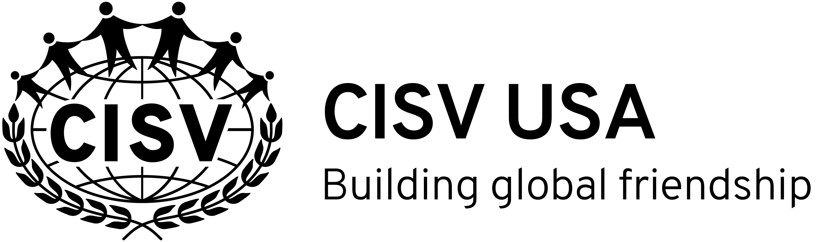
SEMINAR CAMP 2020 PARTICIPANT APPLICATION FORM
To be completed by all USA applicants to CISV Seminar Camps
during the summer of 2021 and the winter of 2021-2022.

Personal Information
First Name
Last Name
Chapter
Number & Street
City
State, Zip Code
Home Telephone
Cell Number
Applicant’s Email
Date of Birth* (Day/Month/Year)
Gender Identity
Parent/Guardian Name & Email
Parent/Guardian Name & Email

*Please provide a copy of your birth certificate, passport, or other document that verifies your date of birth.

Have you applied for Seminar Camp before? Yes ☐ No ☐
If Yes, please indicate why you were unable to participate.

Have you been involved in CISV before? Yes ☐ No ☐
If Yes, which programs?
Village ☐ Interchange ☐ Step Up☐ Youth Meeting ☐ JC ☐ Junior Branch ☐
Personal References
Please ask two persons who know you well to provide letters of reference. One should be from a chapter member and one from someone outside CISV. There is no specific form for the letter and it should be emailed to Seminar@cisvusa.org
REFERENCE NAME | RELATIONSHIP TO APPLICANT
1.
2.
It is the applicant’s responsibility to ensure that the written references are submitted to the National Office by the national deadline. Ideally, written references should be submitted simultaneously with the applicant’s completed application. The Local Seminar Chair is not responsible for collecting written references and the application is not complete until the written references are received.

Chapter Recommendation
It is the responsibility of every participant to inform their chapter of their application and encourage them to send an endorsement from their Local Seminar Chair, Chapter President, or other chapter officer. Endorsements and other comments should be sent to the National Office by the national deadline.
NOTE: The selection committee will also be happy to receive recommendations from officers/members of the chapter.

Destination Preferences:

Rank every camp with a ranking of P (meaning Preferred, this camp is a top choice), Y (meaning Yes, I will accept if invited), or N (meaning No, I cannot attend this Seminar). You may rank as many camps in each category as you like. Any camp without a ranking will be considered a No. The national Seminar selection committee will do its best to assign you according to your preferences, but not all applicants will receive an invitation to one of their top choices. Rank all camps!
- It is suggested that you investigate airfares while making your choices so there are no surprises later. Also, please discuss choices with your parents before submitting your application.
- Final dates are not confirmed until February for summer Seminar Camps & October for winter Seminar Camps. Do not buy an airline ticket until you have received confirmed camp dates.

Reference | Host NA/PA | Chapter | Dates | Gender | Airport | RANK (P,Y, N)
S-2021-001 | Argentina | Buenos Aires | 27/12/2021-16/01/2022 | F | EZE
S-2021-001 | Argentina | Buenos Aires | 27/12/2021-16/01/2022 | M | EZE
S-2021-002 | Brazil | Rio de Janeiro | 11/07/2021-31/07/2021 | M | GIG
S-2021-002 | Brazil | Rio de Janeiro | 11/07/2021-31/07/2021 | F | GIG
S-2021-003 | Brazil | Sao Paulo | 28/12/2021-17/01/2022 | F | GRU
S-2021-003 | Brazil | Sao Paulo | 28/12/2021-17/01/2022 | M | GRU
S-2021-005 | Czech Republic | Prague | 04/07/2021-24/07/2021 | M | PRG
S-2021-005 | Czech Republic | Prague | 04/07/2021-24/07/2021 | F | PRG
S-2021-006 | Denmark | Midtjylland | 02/07/2021-22/07/2021 | F | CPH
S-2021-006 | Denmark | Midtjylland | 02/07/2021-22/07/2021 | M | CPH
S-2021-007 | Egypt | Cairo | 27/06/2021-17/07/2021 | F | CAI
S-2021-007 | Egypt | Cairo | 27/06/2021-17/07/2021 | F | CAI
S-2021-007 | Egypt | Cairo | 27/06/2021-17/07/2021 | M | CAI
S-2021-008 | France | Provence | 09/07/2021-29/07/2021 | F | MRS | 18 years only
S-2021-008 | France | Provence | 09/07/2021-29/07/2021 | M | MRS | 18 years only
S-2021-009 | Germany | Luneburg | 01/08/2021-21/08/2021 | F | HAM
S-2021-009 | Germany | Luneburg | 01/08/2021-21/08/2021 | M | HAM
S-2021-011 | Iceland | Reykjavik | 21/06/2021-11/07/2021 | F | KEF
S-2021-011 | Iceland | Reykjavik | 21/06/2021-11/07/2021 | F | KEF
S-2021-011 | Iceland | Reykjavik | 21/06/2021-11/07/2021 | M | KEF
S-2021-013 | Mexico | Mexico City | 04/07/2021-24/07/2021 | F | MEX
S-2021-013 | Mexico | Mexico City | 04/07/2021-24/07/2021 | M | MEX
S-2021-014 | Netherlands | Amsterdam | 23/07/2021-12/08/2021 | F | AMS
S-2021-015 | Norway | Hordaland-Nordhordland | 25/06/2021-15/07/2021 | F | BGO
S-2021-015 | Norway | Hordaland-Nordhordland | 25/06/2021-15/07/2021 | F | BGO
S-2021-015 | Norway | Hordaland-Nordhordland | 25/06/2021-15/07/2021 | M | BGO
S-2021-016 | Portugal | Lisbon | 23/07/2021-12/08/2021 | F | LIS
S-2021-016 | Portugal | Lisbon | 23/07/2021-12/08/2021 | M | LIS
S-2021-019 | Sweden | Goteborg | 18/06/2021-08/07/2021 | F | GOT
S-2021-019 | Sweden | Goteborg | 18/06/2021-08/07/2021 | M | GOT
S-2021-020 | USA | Detroit | 23/07/2021-12/08/2021 | M | DTW
S-2021-020 | USA | Detroit | 23/07/2021-12/08/2021 | F | DTW

- Invitations in Bold mean that CISV USA did not receive first round invitations to these camps. Nevertheless, please rank them. We could receive a late invitation.
*Participants for the Seminar in France, must be 18 on the first day of the program to comply with local laws. Do not rank this camp f you will not be 18 by the start of camp.
If you ranked any camps N (No), please briefly explain why.

Application Essay:
Please choose one of the questions below and write an answer using no more than one side of a standard 8 ½ by 11 page.
- Seminar Camps can really be fun but can also be very challenging. What do you think would be the best kind of Seminar Camp for you and how might you try to make it that way?
- How can you be open-minded without risking the loss of who you are?
- Was there a time you really had to stand up for something you believed in? Please describe it. Were you right?

Applicant Verification
I am submitting my application for participation in an International CISV Seminar Camp. I have read, understand, and agree to:
- Respect the decisions of the Seminar Camp Chair and committee.
- Respect the CISV requirements on Behavior and Cultural Sensitivity, as outlined in Info File R-07;
(copy and paste this link to download Info File R-07: http://www.cisv.org/EasySiteWeb/GatewayLink.aspx?alId=2139).
- Participate in all Seminar Camp participant preparation offered.
- Participate in local Junior Branch (JB) activities before and after my Seminar Camp experience.

 | Signature | Date
Applicant

Parent / Guardian Verification
I/We are aware of and fully support my child/our child’s application for participation in an International CISV Seminar Camp. I/We have read, understood, and agree to:
- Respect the decisions of the Seminar Camp Chair and committee.
- Ensure that our child participates in all Seminar Camp participant preparation.
- Encourage our child to participate in local Junior Branch (JB) activities before and after his/her program.
- Assist our child with Seminar Camp preparations, including (but not limited to) health, legal, travel, and forms.

 | Signature | Date
Parent/Guardian
Parent/Guardian

Seminar Camp Fees
All fees for Seminar Camp will be collected by the home chapter and must be received as the chapter’s policies indicate. Should a participant withdraw after accepting a placement, that participant’s camp fees are non-refundable unless a replacement participant is found. Should an applicant not receive a placement, or have his/her camp cancelled and no suitable replacement invitation is available, any fees that applicant has paid will be refunded.
Questions about fees should be directed to your Local Seminar Chair or Chapter President.
Application Deadlines
CISV USA Deadline: The National Office must receive completed applications by December 15, 2019. Late applications may be accepted. However, those received by the deadline will receive priority. For questions or concerns, please contact the National Seminar Camp Chair, Julia Beasley current chair at seminar@cisvusa.org) or the Executive Director (cisvusa@cisvusa.org).

