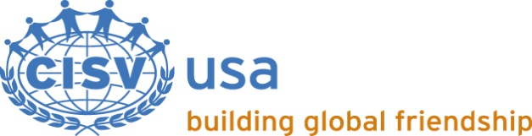
RELEASE OF LIABILITY FOR TRAVEL OUTSIDE CISV PROGRAM DATES
This form is to be completed and signed by both of the parents/legal guardians of any child participant who is a member of a delegation whose travel to and/or from a CISV Village, Step Up, Interchange, or Youth Meeting is in violation of the following portion of the CISV USA Travel Policy:
Village, Interchange, Step Up and Youth Meeting delegations shall travel to and from the site of the approved CISV activity as a group. Travel shall be direct and continuous to and from the CISV activity site. No side trips shall be permitted. No layover in excess of 24 hours shall be permitted unless common carrier schedules require otherwise. Delegation itineraries must be approved by the local Chapter.
By completing this form I confirm that I, the parent of the youth participant named below, have read, and understand, the CISV USA Travel Policy. I acknowledge that my child's current itinerary is in violation of this policy and has not been approved by the local Chapter.
Further, I acknowledge that my child’s itinerary may also be in violation of CISV International’s Universal Travel and Medical Insurance (“CISV Insurance”) which provides coverage as follows:
Period covered: You are covered for the entire period of your CISV international programme or meeting, travel days to and from the event, plus up to 10 extra days of leisure travel (when in line with CISV International’s Programme Basic Rules).
By completing this form I confirm that I, the parent of the child participant named below, have read, and understand, CISV International’s Programme Basic Rules (C-03) for my child’s program. I understand that CISV Insurance coverage is limited to additional travel that conforms with those rules. Accordingly, I hereby assume full responsibility for any and all travel, medical, or other expenses, claims or losses including the risk of bodily injury, death or property damage that may occur as a result of any violation of the CISV USA Travel Policy and/or CISV International’s Programme Basic Rules.
Further, I hereby waive and release any claim against or liability of the CISV Chapter named below, CISV USA, or CISV International Ltd., or any employee, officer, or volunteer of any of them, for any such claim or liability that arises prior to the first day of the CISV program as indicated below (if additional travel will occur prior to the program) or arises after the last day of the CISV program as indicated below (if additional travel will occur after the program ends), other than a claim which is covered by CISV Insurance. I understand and acknowledge that I am solely responsible for arranging suitable insurance coverage for my child for any travel days in violation of the CISV USA Travel Policy and/or CISV International’s Programme Basic Rules, and/or that fall outside the CISV Insurance coverage period.
Youth Participant ___________________________________________________________________
Sending Chapter ____________________________________________________________________
Program Number (e.g. V-17-020/C-16-003/I-16-116/Y-15-015, etc.) __________________________
Host Country _______________________________________________________________________
Program Start Date _____________________ Program End Date __________________________

______________________________________ __________________________________________
Parent’s/Guardian’s Name Parent’s/Guardian’s Name

____________________________________________________ __________________________________________________________
Parent’s/Guardian’s Signature Parent’s/Guardian’s Signature
____________________________________________________ __________________________________________________________
Date Date

