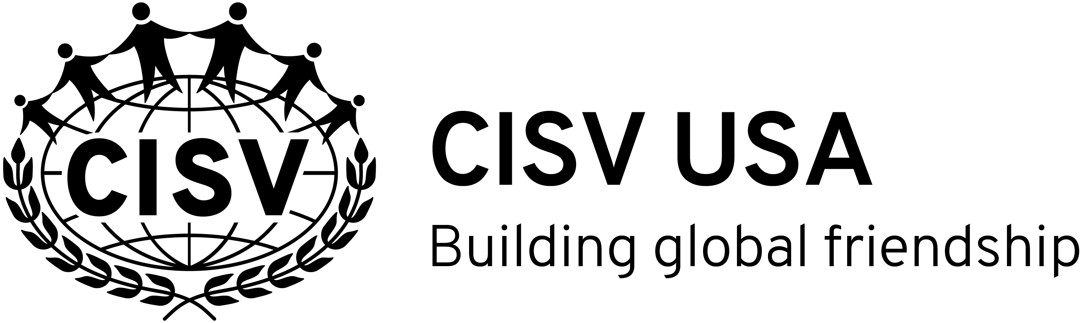

Staff Application Form

Please return this form to (The National Office at cisvusa@cisvusa.org):

If you are filling in the form on the computer, the boxes and page numbers will expand automatically. Otherwise, please feel free to attach additional sheets of paper.

1. The Program you are applying for is:
Program | Position | Year
Fortnight

2. Personal Information:

Given Name
Surname
Number & Street
City
State
Country |  |  | Zip code
 | Country Code | Area Code |  | Local Number
Tel
Mobile Number
E mail

 | (Day / Month / Year) |  | Sex |  | Nationality
Date of Birth
Please also provide proof of age with this application (e.g. copy of birth certificate or driving licence)

Occupation
Employer / Academic Institution (if a student)
Educational Background (degree and year)

3. Please note any Health Restrictions and their effects on your daily life:

4. Areas of interest and ability
Language | Fluent | Good | Fair
In the CISV program, you will need to assist and or assume responsibility for some activities such as music, arts and crafts, games, sports, dance, discussion and swimming etc. Please list your interests and skills, which could be helpful at the program:
Do you have Certification: in | Yes / No | Additional Information
Life Saving
First Aid

5. Experience in working with people in a leadership role and as part of a team:

6. CISV or other experience with children / youth (of similar age to the specific program participants):

7. Other experience in CISV, with other intercultural organizations or with other cultures:

8. Why do you want to be staff for National Camp and why do you think the program is important?
9. References: (2 References are required. Please give an Official CISV Reference Form to your References listed below and ask them to forward the completed forms directly to the person/address at the top of this form.)

Given Name
Surname
Number & Street
City & State
Country |  |  | Zip code
 | Country Code | Area Code |  | Local Number
Telephone Number
E mail

Given Name
Surname
Number & Street
City & State
Country |  |  | Zip code
 | Country Code | Area Code |  | Local Number
Telephone Number
E mail

10. Applicant -- Please certify that:
I will participate in all CISV Leadership Training Sessions required by CISV. I will abide by and uphold CISV Guidelines on Behaviour and Cultural Sensitivity (Info File R-7) and will put the delegates’ interests and welfare above my own while attending the program. I understand that before serving in a staff/leadership position, I must be a member of CISV. I have no criminal convictions or history of mental illness, emotional counselling, violent behaviour, child abuse, drug/alcohol abuse, prejudice etc that would disqualify me from participation in CISV’s international, cross-cultural and peace education programs. I agree to a police record check if required by CISV. I consent to the personal data in this Application Form being used by CISV to process this application and agree that it may be shared with other people involved in organising the programs, wherever they may be hosted. All the information on this application is correct and accurate.

Applicant’s Signature |  |  | (Day / Month / Year)

- CISV Certification to be signed by the CISV member responsible for staff/leader selection in the home NA of the applicant. Sign below if you certify that the above application, references and police checks (where possible according to national law) have been reviewed and found to be satisfactory so that the application is approved.

Signature of CISV member responsible for staff selection.
Please print name |  |  | (Day / Month / Year)

Please understand that staff selection and assignment cannot be made until all necessary documentation has been received and reviewed.

