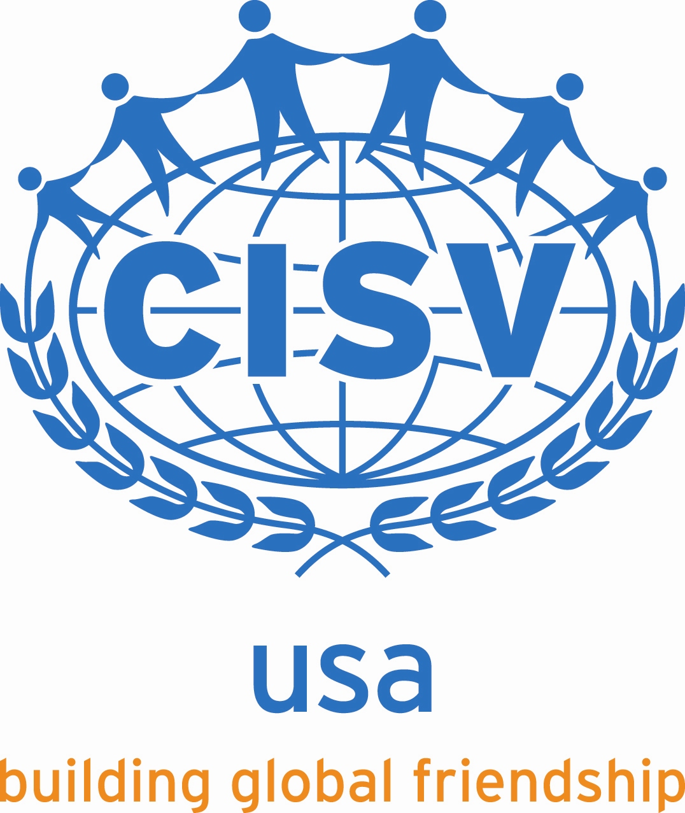
Background Check Questionnaire
and Authorization

Date Requested Requester Name ______________________________

COMPLETE NAME:
First: Last: Middle:

DATE OF BIRTH:

LIST OTHER NAMES USED, IF ANY: | DRIVER’S LICENSE STATE AND NUMBER:

Residence Addresses for Past 7 Years beginning with your current address:
Dates – From/To |  | County | Address  City, State, Zip
Have you ever been convicted of or pleaded guilty or nolo contendere to a felony? Yes No

Have you ever been convicted of or pleaded guilty or nolo contendere to a misdemeanor (including DUI convictions)? Yes No

Have you been restrained or enjoined by a court injunction or order? Yes No

 | If yes to any of the above, please describe, including dates, location (city, county, state), nature of violation, details of any injunction or court order (attach additional sheets if necessary):

I certify that the information provided by me in this questionnaire is true and correct. I understand that any falsification, misrepresentation, misleading statement, or omission of fact will be sufficient reason for refusal to allow me to serve as a CISV volunteer. I further acknowledge and agree that this information may be used to determine my eligibility to serve as a volunteer in connection with CISV’s programs and activities.

I hereby authorize CISV USA (including its Chapters) to perform a complete background check on me, including without limitation a complete criminal record check and motor vehicle driving record check, and to perform additional background checks on me from time to time. I further authorize CISV USA to release my name, date of birth, driver’s license number, and state in which that license was granted to CISV USA’s liability insurance carrier, with the understanding that the carrier may, at its discretion, perform its own motor vehicle records check. I hereby release CISV USA and its Chapters, steering committees, officers, directors and volunteers from any claim or liability arising out of the performance of these background checks.

I further acknowledge that I have been advised of and agree to comply with CISV’s policies in connection with the use of a motor vehicle to transport CISV participants, including that any person transporting CISV participants in connection with a CISV program must:
- Be 25 years old or older*;
- Carry automobile liability insurance with minimum limits of at least $100,000 (per accident for bodily injury and property damage) and provide proof of such insurance to CISV;
- Have a clean driving record (no serious infractions and no more than two minor infractions).

*The insurance company has agreed that an Interchange leader who is at least 23 (but not yet 25) and has at least 5 years of driving experience can drive his or her co-leader during the hosting phase. An Interchange leader of this age may not drive youth, a junior leader, or any other CISV participants or volunteers, just the co-leader who is staying with him/her. All other CISV rules requiring a good driving record and adequate insurance apply. This exception does not apply to leaders or staff for any other programs.

Signature: Date:
Consumer Reports Disclosure

We are required by U S. law – the Fair Credit Reporting Act and its amendments, 15 U.S.C §§ 1681-1681u – to notify you that CISV USA, its chapters, steering committees and/or its agents (collectively, “CISV”) may request an investigative consumer report from a consumer reporting agency for the purpose of evaluating your suitability to serve as a CISV volunteer. CISV would request this report as part of our routine background check procedures.

The Fair Credit Reporting Act defines a consumer report, in part, as a report bearing on an individual's creditworthiness, credit standing, credit capacity, character, general reputation, personal characteristics, or mode of living. This includes, but is not limited to criminal and driving records, educational history, and prior employment verification. The report may contain information gathered from public or private sources. For further information you can review a document prepared by the Federal Trade Commission entitled “A Summary Of Your Rights Under The Fair Credit Reporting Act” at this link: http://www.ftc.gov/bcp/edu/pubs/consumer/credit/cre35.pdf.

You have the right under the Fair Credit Reporting Act to receive from LexisNexis a description of the nature and scope of any consumer report that CISV requests. LexisNexis can be reached at 1-800-845-6004.

Authorization

I have read the foregoing Consumer Reports Disclosure and understand its contents. I hereby authorize CISV to request and obtain the above-referenced consumer report at any time prior to or during my service as a CISV volunteer.

Signature: _______________________________________________
Print Name: ______________________________________________
Date: ____________________________________________________

